**Daily Log:**

Shared routes between Cuba and China

*Proposal from Granma Daily*

*for the Silk Road Global News Awards*

**Our vision,**

**shared at the same site**

Ties between Cuba and China have transcended time and are strengthened with new ways to shorten distances. Cooperation in sectors such as science, industry, education and sports is also multiplying with the insertion of Cuban national media, such as Granma, in the Belt and Road News Network.

This media cooperation strengthens the exchange on topics of common interest, and accompanies projects carried out in both nations, in the common path of the construction of Socialism and in the purpose of providing the Global South with stronger voices.  
Granma, Voice of the Communist Party of Cuba Central Comitee has given regular coverage to activities carried out between both Parties, Governments, sectors of the economy, society and the history of both nations. Today, its platforms have a significant archive that illustrates milestones in the relationship between both nations.  
The celebration, in 2025, of the 65th anniversary of diplomatic relations between the two countries, and the 60th anniversary of the founding of Granma, have been the essential reasons for the creation of a new section on the website of the most important Cuban newspaper, dedicated to the shared routes of Cuba and China.

Daily Log (Diarios de Navegación) is already available on our website and will accompany these celebrations, giving informative coverage and with other contents, to the advances in the relationship between both countries.

This is a document describing the main characteristics of Daily Logs, in order to its presentation at the Second Edition of the Silk Road Global News Awards in the category of Best Innovation Award.

***You may visit Daily Log by clicking in the link or scanning the QR code: https://www.granma.cu/diarios-de-navegacion***



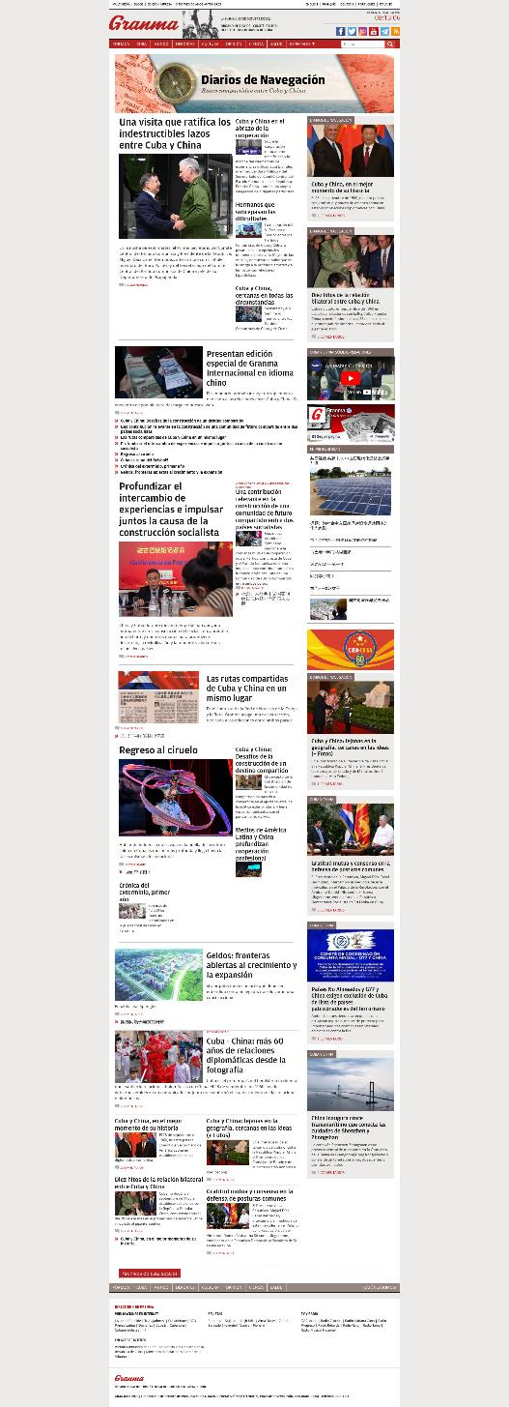**The section**

**at a glance**

Diarios de Navegación includes a variety of contents that have been integrated, for the first time, into a single section of the Granma newspaper, in order to make easier for readers interested in learning more about Cuba-China relations to have all the recently published articles in one place.

**Beyond the website**

Diarios de Navegación has also been presented as a project of the Granma newspaper in other platforms that transcend the website. An example of this was the edition of the weekly Granma International, published on October 23, which had a Chinese version for the first time and was distributed during the VI Theoretical Seminar between the Communist Party of Cuba and the Communist Party of China.

